Course name: AIE425 – Intelligent Recommender Systems

Semester: Fall 2025–2026

Project Title: Sleep Quality Improvement Recommendation Engine

Group Number: 11

Team Members:

- Mohamed Desoky (222101362)
- Nada Gamal (222101750)
- Bishoy Elgendy (222100403)
- Osama Adel Fawzy (222100211)

Instructor:

- Prof. Samy Ghoniemy

Teaching Assistants:

- Eng. Ahmed Salama
- Eng. Mariam Elgohary

Date: January 5, 2026

Introduction

Recommender systems assist users in identifying relevant products or services through the prediction of the most suitable offerings for the user. The most common applications for recommender systems can be found in digital media and online shopping by:
- Providing personalized browsing suggestions
- Reducing information overload
- Improving User Experience
via ranking or suggestion capabilities based on historical activity or input from the user, as well as the availability of other data collected from multiple users.
Recommenders differ from search engines in that the latter allow users to specifically express what they want. In contrast, recommenders typically work in situations where there is an insufficient amount of data to accurately determine what's best for a user. Therefore, they utilize limited known inputs about the user's preference to make assumptions and offer helpful recommendations based on known patterns of behavior and interests of others, who may have selected similar items based on those same patterns.
The basis of recommendation systems is that users exhibit patterns in their preferences. As users make repeated choices from a list of available options, certain items will appeal to certain groups of users, and certain groups of items will appeal to certain types of users. By identifying these patterns of preference, a recommender system can create useful output, such as a predicted rating for an item; ranked lists of recommended items; and similarity measures that compare users and/or items based on their common interests. To be effective in predicting what a user would like based on their past interactions and by recommending new items, effective recommendations must be created while accommodating various obstacles that arise when working with actual user interaction data. Examples of challenges in actual user interaction data include: missing data, variance in user interaction history (i.e., there are some users who are very active while others are less active), and differing popularity levels between the various items being recommended.
In this course project, we will develop and evaluate collaborative and content-based filtering recommendation system pipelines based on the project dataset supplied and through completing required experimental procedures. Presenting our work in an orderly fashion will reflect our use of the prescribed workflow for developing recommendation systems: building the data set, implementing agreed-upon recommendation strategies, producing recommendations (ranking output) and evaluating and contrasting our findings. Beyond merely reporting output recommendations, our focus must also include the identification of the specific application of each algorithm/approach, the theoretical premise under which it operates, and how the communicated recommendations differ from one project to another as a result of varying models.

Why Dimensionality Reduction

In recommender systems, the interaction space can be extremely high-dimensional because each user can be represented by a vector over a large set of items, and each item can be represented by a vector over a large set of users. When the number of users and items is large, direct modeling and similarity computations in this original space become computationally expensive. In addition, real user–item matrices are highly sparse, meaning most entries are missing because users typically rate only a small portion of the available catalog. This sparsity can make direct similarity estimates noisy and unstable, especially when two users or two items share only a small overlap of observed ratings.
Dimensionality reduction addresses these issues by compressing the high-dimensional interaction space into a lower-dimensional representation that captures the dominant structure in the data. Instead of relying on raw sparse vectors, the system uses a smaller set of components or latent factors that summarize the main patterns of preference and co-variation. This reduces computation and can improve stability by emphasizing shared structure and reducing the impact of missing entries and noise.
Through Dimensionality Reduction, Compact Representations that can lead to Predictions and Comparisons of Predictive Performance, are produced in this Project explicitly and help to provide ratings based on the way that each model has been constructed. Furthermore, Compact Representations allow us to analyze the impact of Neighbourhood Size and Latent Rank on prediction behaviour, Robustness and Sensitivity to Sparsity when making Rating Predictions from the Models.

Why Hybrid Recommender Systems

Recommender systems that utilize only one source of information are often faced with the problem of predictable limitations. Content, based recommendation identifies those items which have similar features to what a user has already liked by using item attributes. The method can result in good performance if item descriptions are informative and well, engineered, however, the problem of over, focusing on narrow similarity and missing broader patterns that arise from the collective user behavior can still exist. Additionally, it may find it difficult to recommend items that are different in content but still preferred by users with similar tastes.

Collaborative filtering uses useritem interactions to learn community, driven relationships among users and items. It has the ability to detect preference signals that are not directly shown in item attributes, however, it is vulnerable to sparsity and, thus, usually has difficulties in cold, start scenarios. In the case of a user having a very limited interaction history, or an item having few ratings, collaborative methods may not possess enough evidence to make reliable recommendations.

Hybrid recommender systems combine content-based and collaborative signals to balance these strengths and weaknesses. By integrating multiple sources of evidence, hybrid methods can improve robustness when one signal is weak, reduce over-specialization, and improve coverage in sparse or cold-start conditions. For this project, the hybrid approach is included to support stronger recommendations by leveraging both item information and user–item interaction patterns in a single combined scoring framework.

Project Objectives and Report Scope

The goals of this course project are to implement and analyze recommender, system methods as per the project framework, and to document the results through the outputs produced. The project is about constructing recommendation workflows that can predict user preferences and generate recommendations by applying structured modeling steps, and then comparing the behavior and performance of the different approaches and settings.

Further, the project stresses two complementary directions. First, it uses dimensionality, reduction and factorization, based methods to represent useritem interactions in a compact way and to facilitate rating prediction in controlled configurations. Second, it employs content, based, collaborative, and hybrid recommendation workflows to produce ranked recommendation outputs and to evaluate them by the given evaluation metrics. Hence, the report details each required workflow step, by, step and provides a summary of the results and comparisons that are the immediate corollary of the project outcomes.

What Section 1 and Section 2 Cover

Section 1

dives deep into dimensionality reduction and matrix factorization techniques that are used to make recommendation, style predictions.
Initially, it uses PCA based on a mean, filling assumption to determine itemitem covariance, find the Top, 5 and Top, 10 peer items for chosen targets, and create predicted ratings for a selected test user.
After that, a second PCA workflow is implemented which utilizes an overlap, aware covariance estimation method (MLE, style handling of missing values). The comparison of predictions between mean, filling covariance and overlap, aware covariance for the same targets and user under Top 5 and Top, 10 neighborhoods is presented side by side.

At the end, Section 1 employs SVD and truncated SVD to achieve low, rank reconstructions, contrasts reconstruction behaviors at different latent ranks, produces rating predictions for selected target users and items, compares prediction accuracy to a baseline, and goes beyond to include additional analyses such as reporting of computational efficiency, latent factor interpretation with latent, space visualization, sensitivity/robustness testing, and a cold, start simulation with performance reported.

Section 2

mainly describes the creation of recommendation models that utilize content and interaction signals, which are then merged in a hybrid framework. To begin with, it shows the data preparation steps and feature construction required for recommendation. Then, it puts into practice content, based recommendation (derived from item representations and similarity), collaborative filtering recommendation (derived from useritem interaction patterns), and a hybrid approach that merges content, based and collaborative scores via a specified weighting strategy. Section 2 ends with the evaluation and comparison of methods through the ranking, based metrics that have been reported, thus, providing the quantitative results for the tested approaches under the necessary evaluation setup.

SECTION 2

Section 2 implements a domain-specific recommender system for sleep quality improvement products/apps using the provided synthetic dataset. The dataset used in this section consists of 5,000 users (users shape: (5000, 14)), 520 items (items shape: (520, 8)), and 51,488 ratings (ratings shape: (51488, 5)). After cleaning, the ratings data remains (51488, 5), with ratings already within the 1–5 range. The resulting user–item interaction space is highly sparse, with sparsity level 0.9802 (98.02%). The rating distribution is: 1 → 2,561; 2 → 5,123; 3 → 10,262; 4 → 15,462; 5 → 18,080. A popularity concentration check shows that the top 20% of items account for 22.88% of all ratings, indicating the long-tail effect is present but not extremely concentrated in a small set of item
The content-based methodology involves using the reviews of a product and combining that with related product information to generate vector representations of each item. The TF-IDF method to extract features is utilized with the parameters of stop_words = "english", maximum number of features = 5000, and ngram_range = (1,2). Using these parameters, a feature matrix is created with a size of (520, 2388). The final feature matrix has dimensions of (520, 2398) because of the category one-hot features and one numeric feature (average rating). The dimension of the item-item similarity space in the content-based approach is (520, 520). To assist with cold-start recommendations, a fallback 'popular items' list was generated, based on the top items having the corresponding item_ids of 40, 495, 62, 342, 442, 247, 490, 132, 378, and 303. The collaborative filtering component uses a user-item rating matrix with dimensions of (5000, 520). User-item ratings are evaluated to compute the user-based CF similarity matrix and the matrix factorization method of SVD is used with 20 latent factors (k=20). In the demo application of numerical prediction in the collaboration, the target user ID is 1 and the target item ID is 1, with a predicted rating of 4.33. Finally, a hybrid procedure takes place in which content-based and CF scores are weighted together as a hybrid approach.
The use of alpha values of 0.3, 0.5, and 0.7 were analyzed, and cold-start evaluations were based on the selected cold-start users: user_id 3844 (3 ratings), user_id 3440 (5 ratings) and user_id 4086 (10 ratings). In the end, the quantitative comparison for the three Hybrid approaches and other baseline methods utilized an evaluation setup of 50 users, reporting HR@10 and NDCG@10 for the baselines. The results of this evaluation indicated Random: HR@10 = 0.00; NDCG@10 = 0.00, Popularity: HR@10 = 0.00; NDCG@10 = 0.00, Pure CB: HR@10 = 0.02; NDCG@10 = 0.006021, Pure CF: HR@10 = 0.04; NDCG@10 = 0.025781. Hybrid: HR@10 = 0.04; NDCG@10= 0.03. The Hybrid approach had the highest NDCG@10 (0.03) and tied for the best HR@10 (0.04) for all three Hybrid approaches, demonstrating that it outperformed Pure CB and matched Pure CF for HR@10 but had the best ranking.

Domain Analysis and Data Preparation

The Sleep Quality Improvement Recommendation Engine provides recommendations corresponding to "Sleep-related Products, Services, Applications" that assist users in Coping/Managing their Sleep Problems. There exists a catalog of 520 items and 5,000 users. The catalog is represented in the form of a matrix with the number of columns equal to that of the number of users and the number of rows equal to that of the number of items (item_id). In total, there exist 51488 unique historical records of user-item interactions, with explicit ratings as historical interaction values.
Each item has been categorized using the available item metadata and based on the type of recommendation(s) generated previously, these categories are: Mobile Apps; Wearable Devices; Supplements; Bedding & Accessories; Sound & Environment; Therapy & Counseling; Lifestyle Practices; Medical Devices; Sleep Aids.
The Users identified in this section have a unique user_id, which identifies their profile, and the Items referred to in this section are identified with a constituent item_id. The Objective of Recommendation is to rank and recommend to Users items they have not yet rated using a combination of behavioral signals (Ratings) and item content signals (item description, category, features_json, average rating from item data).
The characteristics of our subject dataset (our ratings table) and the subsequent needs of our modeling process raise two separate issues. Both issues are related to our sparse data and the interactions between our users and items.

According to the formal definition of sparsity for collaborative filtering, since our dataset contains 5,000 users and 520 items, with a total of 51,488 ratings, our dataset has a sparsity level of 0.9802 (98.02% sparse). Because of this, there will be little to no overlap between users in our dataset, and little to no overlap between items within our dataset, making similarity-based approaches much more difficult when attempting to identify strong evidence of similarity through shared interactions. The second issue is that we have cold-start behavior occurring with our dataset. Some of our users will have a very limited history of ratings associated with them (for example, some of our users will have three ratings or five ratings, and these users will be treated as explicit examples of coldstart behavior). Because of these two considerations, we will want to develop hybrid models and incorporate content features as well as collaborative characteristics into our models to avoid relying solely on the collaborative signals.

The dataset we will be working with in Section 2 is comprised of three main tables: users (5,000 rows), items (520 rows), and ratings (51,488 rows). As part of our content-based modeling, we will also use a reviews table (41111 (rows), 8(columns)) as an additional text-based resource to help us provide enhancement to the representation of items. In addition to the above, our ratings table consists of 5 columns, each column contains a different identifier, including rating_id, user_id, item_id, rating, and date. From our preview of our dataset, we found that all of these identifiers are populated consistently.
Data preprocessing and validation. Data quality checks on the ratings table show no missing values across rating_id, user_id, item_id, rating, or date (all missing counts are 0). Duplicate row detection in ratings reports 0 duplicate rows, and the cleaned ratings dataset retains the same shape after cleaning, (51488, 5). Ratings are already scaled within the required 1–5 range, with the observed rating range reported as [1, 5], so no rescaling is required for compliance with the project’s rating scale requirement.
Basic statistics and distribution. The cleaned interaction data includes 5,000 unique users, 520 unique items, and 51,488 total ratings. The sparsity level is 98.02%, reflecting a sparse user–item space. The rating distribution is skewed toward higher ratings: 1 → 2,561; 2 → 5,123; 3 → 10,262; 4 → 15,462; 5 → 18,080. This distribution indicates that positive feedback (ratings 4–5) dominates the dataset, which is important when interpreting recommendation outputs and when selecting evaluation procedures and baselines
A simple exploratory analysis and long-tail check was performed. To view the user activity and item popularity, the number of ratings per user and number of ratings per item were plotted in the form of distributions. This graphic shows the distribution of rating engagement among the users, meaning that there are a variety of users whose number of rated items differs; also, it provides a clear picture of where on the spectrum each user falls in terms of rating, as well as the relative distribution of rater's attention to certain items. This graphical representation aids in understanding the degree of either sparsity or reliability of similarities and potential popularity bias.

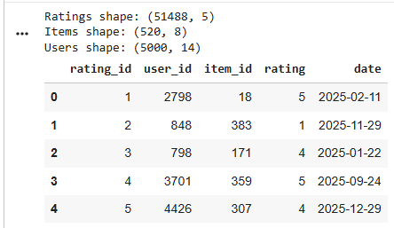

Ratings Table Preview (Dataset Shapes + Sample Rows)

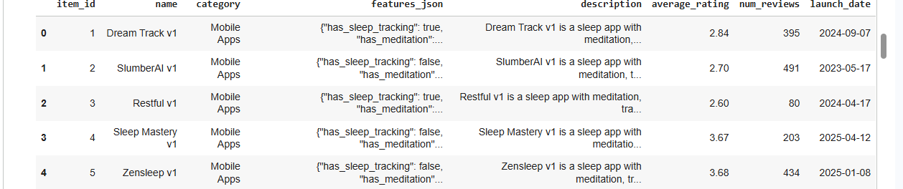

Items Table Preview (Item Metadata: category, features_json, description, avg rating, etc.)

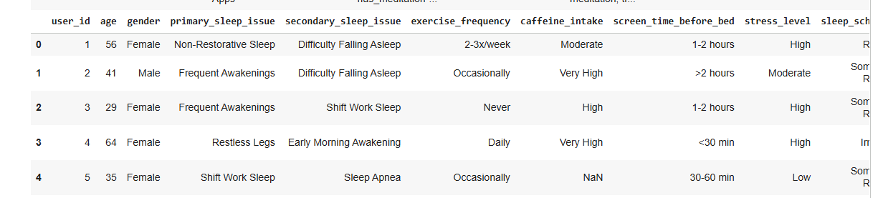

Users Table Preview (User Profile Fields — Part 1)

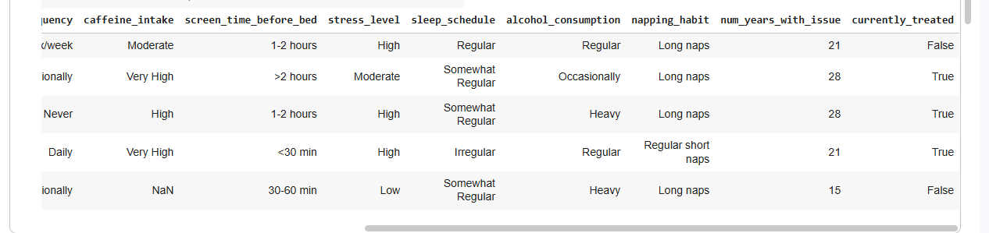

Users Table Preview (User Profile Fields — Part 2 / Continued Columns)

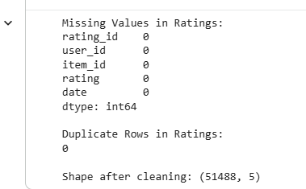
Ratings Data Quality Check (Missing Values, Duplicates, Cleaned Shape)

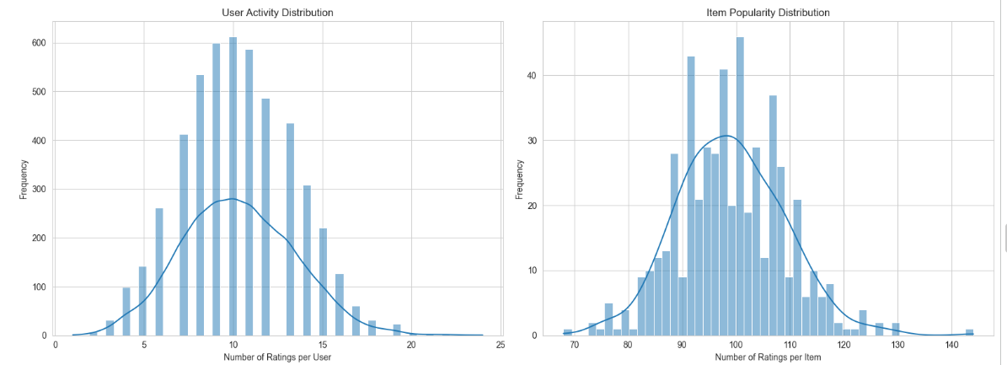

Distributions Overview: User Activity vs Item Popularity

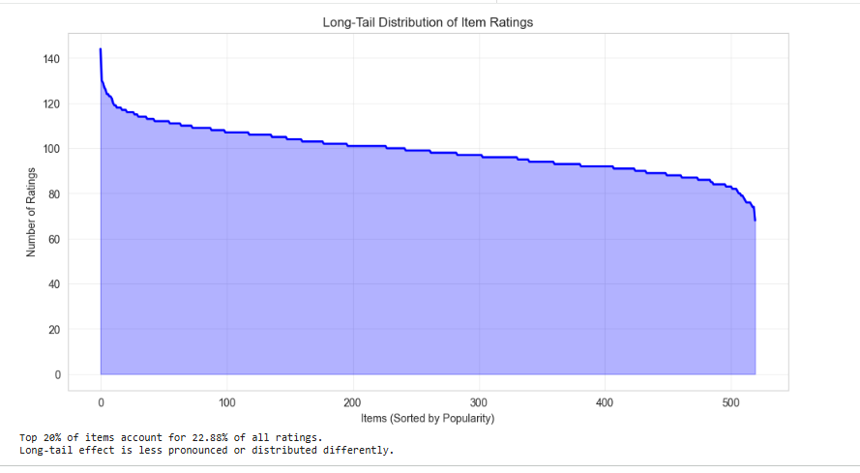

Long-Tail Distribution of Item Ratings (Popularity Rank Curve)

Content-Based Recommendation
A content-based recommendation system uses both the content of an item as well as the user reviews to create a vector-based representation for each item in the database. This vector-based representation is then matched against a user's profile to determine if there is interest in the particular item by means of cosine similarity. To support the processing of many datasets,
has the capability of auto-discovering key fields within the input data and validating the names of the columns it finds. The auto-discovery process found the following column names from the datasets used for this purpose: ITEM_ID (from items) = item_id, ITEM_ID (from ratings) = item_id, ITEM_ID (from reviews) = item_id, TEXT = review_text, CATEGORY = category, and TITLE = name.
Exploratory analysis from the same ratings dataset was also performed within the content-based workflow to understand activity patterns prior to building item representations. The user activity distribution summarizes how many ratings each user contributes, while the item popularity distribution summarizes how many ratings each item receives. These distributions provide context for sparsity and explain why cold-start handling and hybrid methods are necessary.

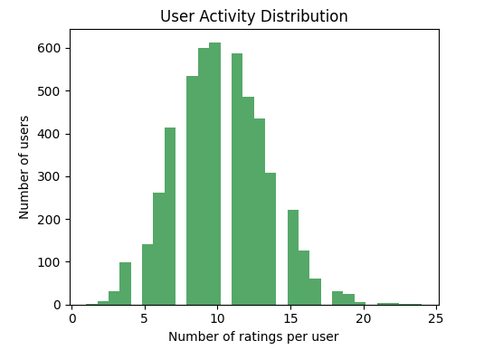

User Activity Distribution (Ratings per User)

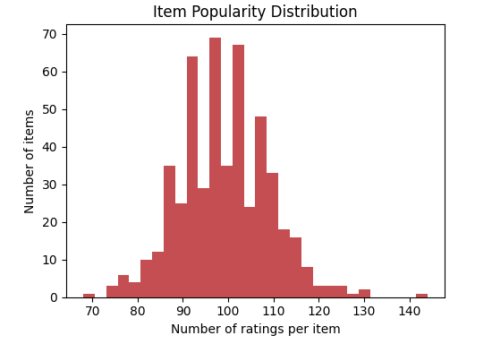

Item Popularity Distribution (Ratings per Item)

The item text is created by taking all review_texts of one item and concatenating them into one item_text field. All the reviews collectively are used to describe how the users perceive that item and what they think about it. Finally, the item_text is combined with the items table in order to provide the textual work for subsequent vectorization.

The TF-IDF method applies tokenisation and use of stop words ("english") to the item_text dataset. max_features = 5000, ngram_range = (1, 2). The resulting TF-IDF matrix for item text will have shape of (520, 2388) which describes 520 total items with 2,388 learned text features.

One-way to include structured item data (in addition to text) into the item characteristic matrix is to augment the TF-IDF data features with Type one-hot encodings of categories and a numeric quality/popularity score of an item calculated from the average rating. The average rating will be determined from rating data combined with average rating data provided into the item characteristic table. Average ratings with NULL values were populated using the mean of avg_rating. Finally, combined TF-IDF text features, category features, and avg_rating will result in a matrix of item features, which will have a shape of (520, 2398) being created for content-based model development.
For a given user_id, UserProfile is an average (weighted by ratings) of the feature vectors from all items rated by that user. To calculate a UserProfile, maps all items rated by the user into feature space and calculates the weighted sum of those feature vectors using the user's rating values, normalized by the sum of the ratings, along with a small numerical stabilization term (+1e-9). If the user does not have any usable rating history for any of the items in feature space, then the UserProfile for that user will be NULL.

To create a user profile, where no user ratings are available, will return a set of recommended "popular items," based on the items with the highest average rating, as defined by item_id. The list of popular items returned from the cold-start fallback, for example, would contain these ten items: [40, 495, 62, 342, 442, 247, 490, 132, 378, 303].

An example of a user using the cosine-similarity recommendation algorithm is given (user_example). In this example case, user_example corresponds to ratings2["user_id"].iloc[0]. To find the list of recommended items for user_example, the cosine similarity between the user_profile of user_example with every item vector will be computed, ranking each item towards the top and eliminating the rated items. The content-based Top20 recommendations for user_example are shown
• item_id 240, “Premium Sleep Solution 240”, category “Bedding & Accessories”, score 0.971844
• item_id 247, “Premium Sleep Solution 247”, category “Bedding & Accessories”, score 0.971703
• item_id 480, “Premium Sleep Solution 480”, category “Therapy & Counseling”, score 0.971370
• item_id 235, “Premium Sleep Solution 235”, category “Bedding & Accessories”, score 0.970899
• item_id 271, “Premium Sleep Solution 271”, category “Bedding & Accessories”, score 0.970612
• item_id 490, “Premium Sleep Solution 490”, category “Therapy & Counseling”, score 0.970477
• item_id 256, “Premium Sleep Solution 256”, category “Bedding & Accessories”, score 0.969570
• item_id 254, “Premium Sleep Solution 254”, category “Bedding & Accessories”, score 0.969441
• item_id 278, “Premium Sleep Solution 278”, category “Bedding & Accessories”, score 0.969334
• item_id 493, “Premium Sleep Solution 493”, category “Therapy & Counseling”, score 0.969273
item_id 261, “Premium Sleep Solution 261”, category “Bedding & Accessories”, score 0.969247
item_id 465, “Premium Sleep Solution 465”, category “Therapy & Counseling”, score 0.968916
item_id 467, “Premium Sleep Solution 467”, category “Therapy & Counseling”, score 0.968806
item_id 489, “Premium Sleep Solution 489”, category “Therapy & Counseling”, score 0.968752
item_id 471, “Premium Sleep Solution 471”, category “Therapy & Counseling”, score 0.968662
item_id 500, “Premium Sleep Solution 500”, category “Therapy & Counseling”, score 0.968583
item_id 495, “Premium Sleep Solution 495”, category “Therapy & Counseling”, score 0.968542
item_id 479, “Premium Sleep Solution 479”, category “Therapy & Counseling”, score 0.968532
item_id 274, “Premium Sleep Solution 274”, category “Bedding & Accessories”, score 0.968360
item_id 513, “Premium Sleep Solution 513”, category “Therapy & Counseling”, score 0.968331

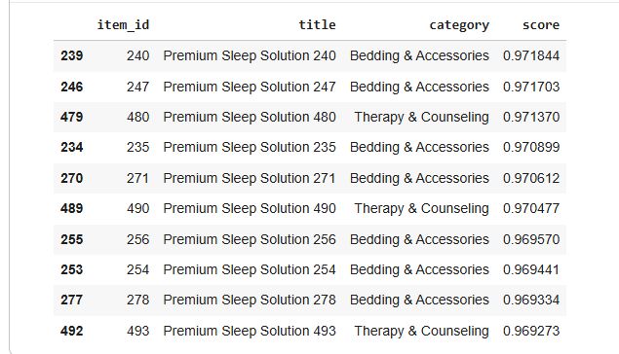

Content-Based Recommendations Output (Top-20 — First Part)

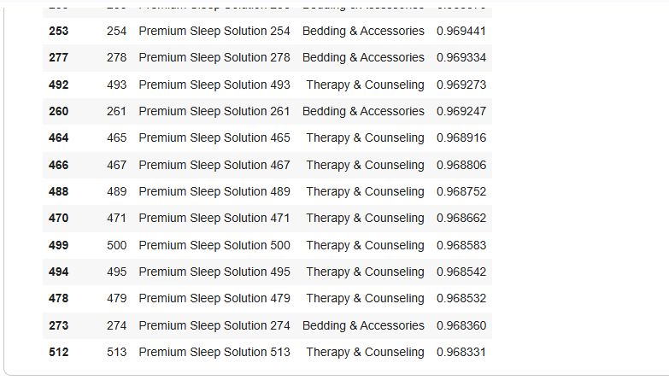

Item-Based kNN Recommendations (Top-10 by Predicted Rating)

Item-based kNN prediction variant (k = 10). In addition to direct profile-to-item similarity ranking, implements an item-based kNN predictor that estimates a user’s rating for a target item using the user’s ratings on similar items. The method computes an item–item cosine similarity matrix over X_item, selects the top k most similar items to the target item (excluding itself), and forms a weighted average of the user’s ratings on those neighbors using similarity weights (with +1e-9 numerical stabilization in the weighted average). Using k = 10, the kNN Top10 recommendations (ranked by predicted rating) for user_example are:
• item_id 14, pred_rating 5.0, “Relax & Restore v2”
• item_id 38, pred_rating 5.0, “SleepWell v4”
• item_id 286, pred_rating 5.0, “Breathing Technique Workshop”
• item_id 288, pred_rating 5.0, “CBT-I Program”
• item_id 312, pred_rating 5.0, “CBT-I Program”
• item_id 319, pred_rating 5.0, “Sleep Psychology Course”
• item_id 325, pred_rating 5.0, “Mindfulness Training”
• item_id 328, pred_rating 5.0, “CBT-I Program”
• item_id 329, pred_rating 5.0, “Meditation Course”
• item_id 331, pred_rating 5.0, “Yoga for Sleep”

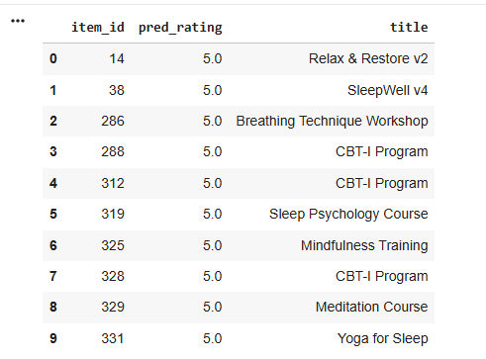

Item-Based kNN Recommendations (Top-10 by Predicted Rating)

Content-based recommendation output (cosine similarity ranking). demonstrates the content-based recommender on an example user defined as user_example = ratings2["user_id"].iloc[0]. Using top_n = 20, the Top-20 recommended items returned by cosine similarity (excluding items already rated by the user) are:
- item_id 240, “Premium Sleep Solution 240”, category “Bedding & Accessories”, score 0.971844
- item_id 247, “Premium Sleep Solution 247”, category “Bedding & Accessories”, score 0.971703
- item_id 480, “Premium Sleep Solution 480”, category “Therapy & Counseling”, score 0.971370
- item_id 235, “Premium Sleep Solution 235”, category “Bedding & Accessories”, score 0.970899
- item_id 271, “Premium Sleep Solution 271”, category “Bedding & Accessories”, score 0.970612
- item_id 490, “Premium Sleep Solution 490”, category “Therapy & Counseling”, score 0.970477
- item_id 256, “Premium Sleep Solution 256”, category “Bedding & Accessories”, score 0.969570
- item_id 254, “Premium Sleep Solution 254”, category “Bedding & Accessories”, score 0.969441
- item_id 278, “Premium Sleep Solution 278”, category “Bedding & Accessories”, score 0.969334
- item_id 493, “Premium Sleep Solution 493”, category “Therapy & Counseling”, score 0.969273
- item_id 261, “Premium Sleep Solution 261”, category “Bedding & Accessories”, score 0.969247
- item_id 465, “Premium Sleep Solution 465”, category “Therapy & Counseling”, score 0.968916
- item_id 467, “Premium Sleep Solution 467”, category “Therapy & Counseling”, score 0.968806
- item_id 489, “Premium Sleep Solution 489”, category “Therapy & Counseling”, score 0.968752
- item_id 471, “Premium Sleep Solution 471”, category “Therapy & Counseling”, score 0.968662
- item_id 500, “Premium Sleep Solution 500”, category “Therapy & Counseling”, score 0.968583
- item_id 495, “Premium Sleep Solution 495”, category “Therapy & Counseling”, score 0.968542
- item_id 479, “Premium Sleep Solution 479”, category “Therapy & Counseling”, score 0.968532
- item_id 274, “Premium Sleep Solution 274”, category “Bedding & Accessories”, score 0.968360
- item_id 513, “Premium Sleep Solution 513”, category “Therapy & Counseling”, score 0.968331
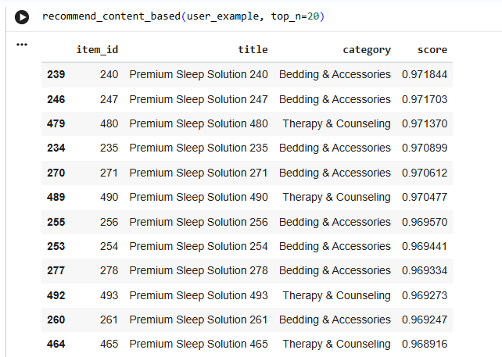

Top content-based recommendations with similarity scores

Continuation of high-ranked recommended items
The item-based k nearest neighbor (kNN) recommendation algorithm produces a list of the ten most highly recommended items, based on predicted rating (k=10) in order of their predicted rating for that particular user. Using the item-based kNN prediction algorithm (k=10), also provides the ten recommended items for the same example_user based on the predicted rating of each candidate item from the user's ratings of those items that are most similar to them (using item-item cosine similarity in their respective feature space). The ten highest ranking items (based on predicted ratings) produced by this algorithm are:
• item_id 14, pred_rating 5.0, “Relax & Restore v2”
• item_id 38, pred_rating 5.0, “SleepWell v4”
• item_id 286, pred_rating 5.0, “Breathing Technique Workshop”
• item_id 288, pred_rating 5.0, “CBT-I Program”
• item_id 312, pred_rating 5.0, “CBT-I Program”
• item_id 319, pred_rating 5.0, “Sleep Psychology Course”
• item_id 325, pred_rating 5.0, “Mindfulness Training”
• item_id 328, pred_rating 5.0, “CBT-I Program”
• item_id 329, pred_rating 5.0, “Meditation Course”
• item_id 331, pred_rating 5.0, “Yoga for Sleep

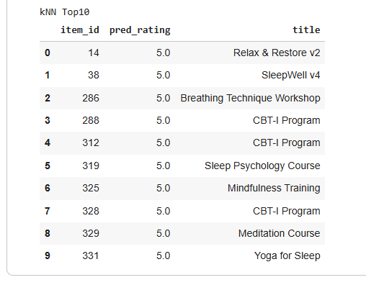

kNN Top-10 Recommendations (Predicted Ratings Table)

In the analysis of Content-Based Similarity Ranking versus Item-Based KNN for the same example user (Step 2), it was observed that the two approaches produced significantly different Top-10 lists for the user under consideration. For example, while the Cosine Similarity based ranking Approach produced a set of recommended items primarily within the Bedding & Accessories and Therapy & Counseling categories, the score for each of those recommended items was very similar (between 0.969 and 0.972), and not far from one another. In contrast, the Top-10 list generated from KNN based recommendations contained programmatic and practice items, for example, CBT-I Program, Mindfulness Training, and Yoga for Sleep; all predicted ratings for these Top-10 items were 5.0 in the output from. The results of this direct comparison indicate that the Ranking Mechanism through Direct Profile-to-Item Similarity Ranking focuses on identifying the closest matches to an individual user's Profile in the Feature Space, and the Ranking Mechanism through KNN Based Prediction focuses on identifying an estimated rating for an item as a function of neighborhood Aggregation.
In order to demonstrate how cosine similarity ranking works in a small dataset, we have created an example with three short text items labeled A, B, and C. We applied the TF-IDF method and calculated the cosine similarities between the TF-IDF vectors and a very simple User Preference Vector (UPV). The final ranking of the three text items can be as follows: Item A (“memory foam mattress soft comfy”) ranked highest with 0.816837; Item C (“gel cooling pillow comfortable”) ranked second at 0.692846; and Item B (“firm mattress provides excellent back support”) ranked lowest at 0.096698. This example demonstrates how the same reasoning applies to the content based approaches, in that higher scoring items based on cosine similarity to the user vector also had the greatest TF-IDF alignment to the user vector.

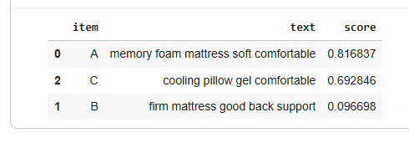
Toy Example: TF-IDF + Cosine Similarity Ranking (Items A/B/C)

Collaborative Filtering and Matrix Factorization
The following process involves using collaborative filtering to identify user preference based on explicit rating data and consequently establish user preference by looking for shared behavioural patterns between users. The input core data tables utilised for this stage of the process are the same tables from Section 2 depicting the Items shape (520, 8), Ratings shape (51488, 5), and Users shape (5000, 14). The ratings were then reshaped to fit into a user–item rating matrix with dimensions (5000, 520) where each row indicates a user_id and each column indicates an item_id.
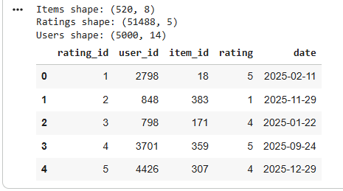

Ratings Table Preview (Repeated Sample / Shapes)

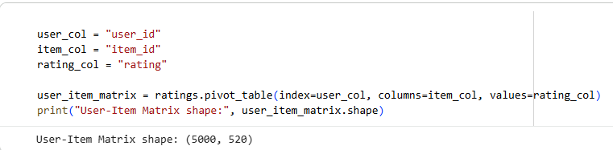

User–Item Matrix Construction (Pivot Table + Matrix Shape 5000×520)

Collaborative Filtering (CF) is a method of predicting ratings for items based on similar users. In CF, user-based collaborative filtering calculates similarities between users and uses the most similar users to make a rating prediction for the target user based on the average deviation of their ratings from their own. shows that the technique produces a User-User Similarity Matrix that is (5000, 5000) in shape.
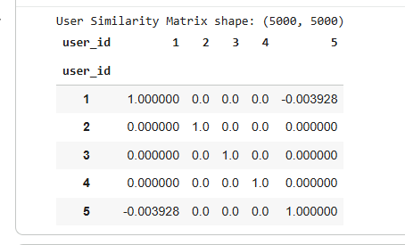

User–User Similarity Matrix Preview (5000×5000 Sample)

For rating prediction, the algorithm identifies all users that have rated the target item, then filters these users down to those whose similarity coefficient was positive in relation to the target user. Afterward, the model gets the top 20 most similar neighbours from those valid users and takes the mean of the target user's individual rating plus the similarity weighted average of neighbour's deviations from their mean rating.

If, in any case, the target user lacks similar neighbour users or has no similarity sum, the predicted rating will be equal to the target users's mean rating. All predicted ratings should be expressed as being within a defined range between 1.0 and 5.0. A sample use of is shown for predicting User 1's rating of Item 1: the prediction created for this item using the CF method was 4.33.

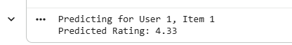

Collaborative Filtering Prediction Example (User 1, Item 1 → Predicted Rating)

Top-10 suggestions for user-based Collaborative Filtering (user_id = 1). To generate recommendations based on users' actions in prior months, predicts ratings for items that have not yet been rated by the user whose rating is being predicted, then numerically ranks the predictions from highest to lowest and returns up to 10 items. The top 10 suggestions for user_id = 1 are:

sold_product_id = 122; predicted_star_rating = 5.000000; product_name = “Valerian Root Extract”; product category = Supplements

sold_product_id = 349; predicted_star_rating = 5.000000; product_name = “Premium Sleep Solution 349”; product category = Medical Devices

sold_product_id = 439; predicted_star_rating = 5.000000; product_name = “Premium Sleep Solution 439”; product category = Sound & Environment

sold_product_id = 491; predicted_star_rating = 4.960391; product_name = “Premium Sleep Solution 491”; product category = Therapy & Counseling

sold_product_id = 273; predicted_star_rating = 4.902703; product_name = “Premium Sleep Solution 273”; product category = Bedding & Accessories

sold_product_id = 420; predicted_star_rating = 4.871805; product_name = “Premium Sleep Solution 420”; product category = Sound & Environment

sold_product_id = 131; predicted_star_rating = 4.867382; product_name = “Magnesium Glycinate”; product category = Supplements

sold_product_id = 315; predicted_star_rating = 4.848346; product_name = “Yoga for Sleep”; product category = Lifestyle Practices

sold_product_id = 471; predicted_star_rating = 4.831259; product_name = “Premium Sleep Solution 471”; product category = Therapy & Counseling

sold_product_id = 65; predicted_star_rating = 4.792470; product_name = “Fitbit NightSense Band”; product category = Wearable Devices

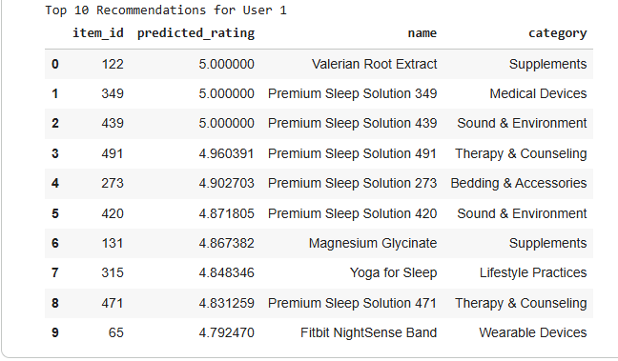

User-Based CF Recommendations (Top-10 for User 1)

The following method used SVD matrix factorization using k=20 latent factors (100%). In addition, in addition to the neighborhood CF methods described uses the matrix factorization method to create a more comprehensive 'dense' prediction space through the use of 'filled' entries where missing values in the user-item interactions matrix have been completed using the item-specific mean fill value (that is: fillna with user-item-mean(axis=0)). The created matrix is then mean centered by using the mean of the user's ratings (that is: user-ratings-mean ). To perform truncated SVD, truncated SVD is performed using k=20 latent factors; the U, σ, and V matrices created during truncated SVD are shown, and are as follows: U= (5000,20); σ= (20,20); and Vt= (20,520). The full reconstructed predicted rating matrix has been reconstructed from the factorization, and has had the mean vector for the users added to each entry in the matrix, in order to return the user prediction rating matrix to the original rating scale.

SVD Top10 Recommendations (for user_id=1). Using the reconstructed predicted ratings (generated by all rated items by user) will generate a ranked list of SVD recommended items for user 1.
• item_id 40, predicted_rating 4.236056, “MindRest v5”, category “Mobile Apps”
• item_id 62, predicted_rating 4.131789, “Eight Sleep BiometricWatch”, category “Wearable Devices”
• item_id 495, predicted_rating 4.130776, “Premium Sleep Solution 495”, category “Therapy & Counseling”
• item_id 342, predicted_rating 4.113560, “Breathing Technique Workshop”, category “Lifestyle Practices”
• item_id 442, predicted_rating 4.108173, “Premium Sleep Solution 442”, category “Sound & Environment”
• item_id 247, predicted_rating 4.095059, “Premium Sleep Solution 247”, category “Bedding & Accessories”
• item_id 378, predicted_rating 4.091839, “Premium Sleep Solution 378”, category “Medical Devices”
• item_id 303, predicted_rating 4.087169, “Sleep Psychology Course”, category “Lifestyle Practices”
• item_id 391, predicted_rating 4.081298, “Premium Sleep Solution 391”, category “Medical Devices”
• item_id 132, predicted_rating 4.079108, “Valerian Root Extract”, category “Supplements”

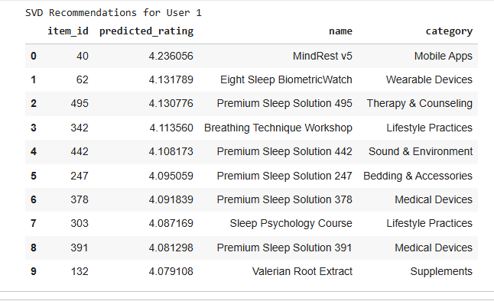

SVD Recommendations (Top-10 for User 1 from Matrix Factorization)

Step 3 - Comparison Within - User Based C.F. vs. S.V.D. (Recommended ListsResults: Both - User Based C.F. versus S.V.D. approaches produce "Predicted List" with Similar Items but also have # Different Score Ranges for the same user id = 1. The "Top 10" User-Based C.F. recommended list consists of several items with Predicted Ratings of 5.000000 and Higher Top5 Ratings than the range displayed within the "Top 10" of S.V.D. down to 4.792470 which was produced through the range of Predictions from the User-Based Reactor Model. On the other hand, the S.V.D. Top-10 Recommended List shows a More Normal Distribution of Predictions over all the ratings produced from 4.236056 down through all the ratings down to 4.079108, based off of the Latent Factor Model and the Average Centered Model prior to Mean Centering and Low Rank Approximation. Both Lists show some Limited Overlap in the Types of Recommendations or Items Recommended, such as Wearable Devices, Sound & Environment, Bedding & Accessories & Supplements, and both Recommended Items within the Top-10 List for the Valerian Root Extracts, having the same Item number 122 in User-Based C.F. and 132 in S.V.D.

Hybrid Recommendation Strategy

In this step, a weighted hybrid recommender combining a content-based score with collaborative filtering score is implemented to provide more robust recommendations on sparsity and cold-start situations. The hybrid method computes one combined score for each candidate item using the weighted combination defined in Section 2, which then allows for ranking the items according to their scores.
Hybrid formulation and candidate set. For a given user_id, the method first collects the set of items already rated by that user and excludes them from recommendation. The remaining items form the candidate set used for scoring and ranking. For each candidate item, two components are computed: (1) a CF-based score derived from the SVD predicted rating matrix (preds_df), and (2) a CB-based score derived from TF-IDF cosine similarity between a user profile vector and each candidate item vector. These two scores are then combined using the weighted rule: combined score = alpha × CB + (1 − alpha) × CF.
To sum up, the CF score from the SVD predictions is sourced from preds_df that corresponds to the desired user across the candidate items. While the SVD predicted ratings were created on the same scale as standard rating systems, the ratings were transformed via min-max normalisation to produce a normalized CF score for each candidate item that can be pooled with cosine similarities (the other half of the hybrid recommender) across the candidate items as they will be relatively parallel with each other.

The content-based score was derived from a user profile created with the TF-IDF item vectors, while creating the TF-IDF item vectors to compute the content-based score, a user profile was created, and selected only those items that were rated 3 or higher. Users without any items rated at least 3 are eligible to have their entire rated item collection included in the creation of their user profile TF-IDF vector. The cosine similarity between the candidate item's TF-IDF vector and the user's profile TF-IDF vector is used to compute the content-based score for that candidate item.
Hybrid output. After combining scores, items are sorted by the combined score in descending order and the top_n results are returned with item_id, name, category, and score. In this step, defines the hybrid function and then tests alpha values required by the specification.
Alpha sensitivity test (validation-style demonstration for user_id = 1). tests three alpha values (0.3, 0.5, 0.7) and shows the top results for user_id = 1. The top-5 recommendations for each alpha are:
Alpha = 0.3 (top 5):

Alpha = 0.3 (top 5):
- item_id 495, “Premium Sleep Solution 495”, category “Therapy & Counseling”, score 0.767483
- item_id 442, “Premium Sleep Solution 442”, category “Sound & Environment”, score 0.761928
- item_id 247, “Premium Sleep Solution 247”, category “Bedding & Accessories”, score 0.759145
- item_id 378, “Premium Sleep Solution 378”, category “Medical Devices”, score 0.755603
- item_id 391, “Premium Sleep Solution 391”, category “Medical Devices”, score 0.746759
Alpha = 0.5 (top 5):
- item_id 247, “Premium Sleep Solution 247”, category “Bedding & Accessories”, score 0.711245
- item_id 378, “Premium Sleep Solution 378”, category “Medical Devices”, score 0.707915
- item_id 442, “Premium Sleep Solution 442”, category “Sound & Environment”, score 0.705403
- item_id 391, “Premium Sleep Solution 391”, category “Medical Devices”, score 0.701597
- item_id 495, “Premium Sleep Solution 495”, category “Therapy & Counseling”, score 0.696600
Alpha = 0.7 (top 5):
- item_id 247, “Premium Sleep Solution 247”, category “Bedding & Accessories”, score 0.663344
- item_id 378, “Premium Sleep Solution 378”, category “Medical Devices”, score 0.660226
- item_id 391, “Premium Sleep Solution 391”, category “Medical Devices”, score 0.656435
- item_id 442, “Premium Sleep Solution 442”, category “Sound & Environment”, score 0.648878
- item_id 358, “Premium Sleep Solution 358”, category “Medical Devices”, score 0.648455

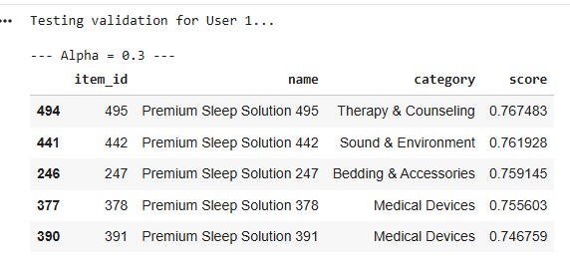

Hybrid Recommender Output ( α = 0.3, Top-5)

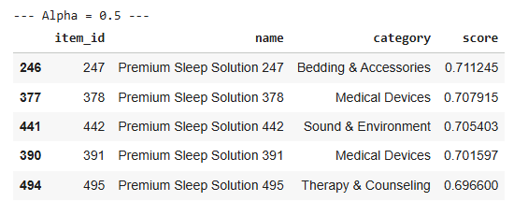

Hybrid Recommender Output (α = 0.5, Top-5)

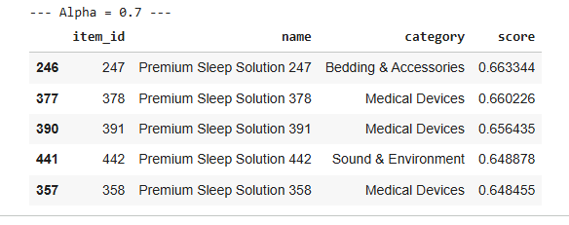

Hybrid Recommender Output (α= 0.7, Top-5)

Changing Alpha Values Affects Item Ranking

In the table below, you can see how varying alpha values may affect the item ranking. An item that has an alpha value of 0.3 might appear ranked as number 1 when compared to items that have alpha values of 0.5. The reverse is also true. An item with an alpha value of 0.5 will be ranked higher than an item with an alpha value of 0.3 if the CF term is normalized. For instance, item_id 495 has a ranking of 1 at an alpha value of 0.3 and a ranking of 5 when the alpha value is 0.5. Conversely, item_id 247 maintains a high ranking through all alpha selections, but becomes the number 1 recommended item when alpha is set to either 0.5 or 0.7. In the case of an alpha = 0.7, item_id 358 is returned as part of the top 5 items because it has a high correlation with the content-based similarity.

Cold Start Users: Hybrid Algorithm vs. Popularity

To demonstrate how hybrid behavior occurs when the user has limited past ratings, we will show examples using three users from the days with the least amount of rating history. User_id 3844 ("3 Ratings") was the first cold-start user. The second cold-start user was user_id 3440 ("5 Ratings"). The third cold-start user was user_id 4086 ("10 Ratings"). will show the past ratings of these three users and their top 5 recommendations based on hybrid usage of alpha = 0.5 as well as the top 5 recommendations based on popularity for each of these three cold-start users.
User 3844 (3-Ratings) history:
- item_id 1, “Dream Track v1”, category “Mobile Apps”, rating 3
- item_id 409, “Premium Sleep Solution 409”, category “Sound & Environment”, rating 4
- item_id 428, “Premium Sleep Solution 428”, category “Sound & Environment”, rating 4
User 3844 hybrid recommendations (alpha = 0.5, top 5):
- item_id 442, “Premium Sleep Solution 442”, category “Sound & Environment”, score 0.731656
- item_id 412, “Premium Sleep Solution 412”, category “Sound & Environment”, score 0.699391
- item_id 425, “Premium Sleep Solution 425”, category “Sound & Environment”, score 0.692227
- item_id 495, “Premium Sleep Solution 495”, category “Therapy & Counseling”, score 0.679222
- item_id 247, “Premium Sleep Solution 247”, category “Bedding & Accessories”, score 0.655971
User 3844 popularity baseline (top 5):
- item_id 40, “MindRest v5”, category “Mobile Apps”, score 4.192285
- item_id 62, “Eight Sleep BiometricWatch”, category “Wearable Devices”, score 4.106515
- item_id 342, “Breathing Technique Workshop”, category “Lifestyle Practices”, score 4.091209
- item_id 442, “Premium Sleep Solution 442”, category “Sound & Environment”, score 4.078022
- item_id 495, “Premium Sleep Solution 495”, category “Therapy & Counseling”, score 4.107574
User 3440 (5-Ratings) history:
- item_id 271, “Premium Sleep Solution 271”, category “Bedding & Accessories”, rating 4
- item_id 139, “Lavender Oil”, category “Supplements”, rating 5
- item_id 483, “Premium Sleep Solution 483”, category “Therapy & Counseling”, rating 4
- item_id 156, “GABA Supplement”, category “Supplements”, rating 5
- item_id 435, “Premium Sleep Solution 435”, category “Sound & Environment”, rating 5
User 3440 hybrid recommendations (alpha = 0.5, top 5):
- item_id 495, “Premium Sleep Solution 495”, category “Therapy & Counseling”, score 0.720547
- item_id 490, “Premium Sleep Solution 490”, category “Therapy & Counseling”, score 0.699297
- item_id 247, “Premium Sleep Solution 247”, category “Bedding & Accessories”, score 0.697769
- item_id 442, “Premium Sleep Solution 442”, category “Sound & Environment”, score 0.696430
- item_id 412, “Premium Sleep Solution 412”, category “Sound & Environment”, score 0.678159
User 3440 popularity baseline (top 5):
- item_id 40, “MindRest v5”, category “Mobile Apps”, score 4.192285
- item_id 62, “Eight Sleep BiometricWatch”, category “Wearable Devices”, score 4.106515
- item_id 342, “Breathing Technique Workshop”, category “Lifestyle Practices”, score 4.091209
- item_id 442, “Premium Sleep Solution 442”, category “Sound & Environment”, score 4.078022
- item_id 495, “Premium Sleep Solution 495”, category “Therapy & Counseling”, score 4.107574
User 4086 (10-Ratings) history:
- item_id 177, “Humidifier”, category “Sleep Aids”, rating 1
- item_id 279, “Premium Sleep Solution 279”, category “Bedding & Accessories”, rating 5
- item_id 476, “Premium Sleep Solution 476”, category “Therapy & Counseling”, rating 5
- item_id 494, “Premium Sleep Solution 494”, category “Therapy & Counseling”, rating 2
- item_id 95, “Samsung NightSense Band”, category “Wearable Devices”, rating 5
- item_id 389, “Premium Sleep Solution 389”, category “Medical Devices”, rating 5
- item_id 504, “Premium Sleep Solution 504”, category “Therapy & Counseling”, rating 5
- item_id 333, “Mindfulness Training”, category “Lifestyle Practices”, rating 5
- item_id 88, “Samsung HeartRate Monitor Elite”, category “Wearable Devices”, rating 5
- item_id 314, “Sleep Hypnotherapy”, category “Lifestyle Practices”, rating 1
User 4086 hybrid recommendations (alpha = 0.5, top 5):
- item_id 495, “Premium Sleep Solution 495”, category “Therapy & Counseling”, score 0.722422
- item_id 378, “Premium Sleep Solution 378”, category “Medical Devices”, score 0.717173
- item_id 480, “Premium Sleep Solution 480”, category “Therapy & Counseling”, score 0.698349
- item_id 490, “Premium Sleep Solution 490”, category “Therapy & Counseling”, score 0.695829
- item_id 391, “Premium Sleep Solution 391”, category “Medical Devices”, score 0.685746
User 4086 popularity baseline (top 5):
- item_id 40, “MindRest v5”, category “Mobile Apps”, score 4.192285
- item_id 62, “Eight Sleep BiometricWatch”, category “Wearable Devices”, score 4.106515
- item_id 342, “Breathing Technique Workshop”, category “Lifestyle Practices”, score 4.091209
- item_id 442, “Premium Sleep Solution 442”, category “Sound & Environment”, score 4.078022
- item_id 495, “Premium Sleep Solution 495”, category “Therapy & Counseling”, score 4.107574

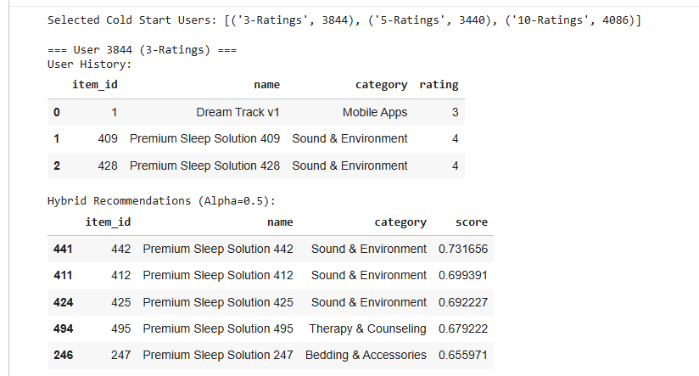
Cold-Start Case: User History + Hybrid Top-5 ( α=0.5)

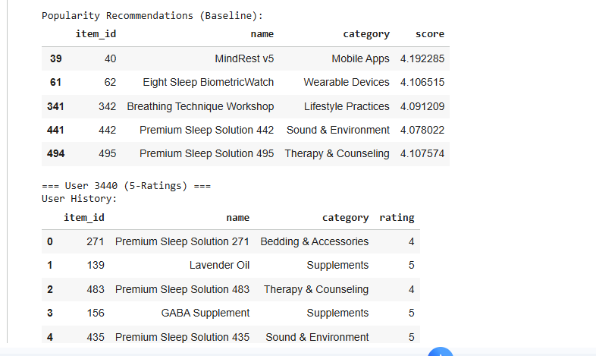

Popularity Baseline + Cold-Start User History

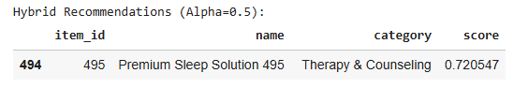
Cold-Start Hybrid Output (Top ranked item snippet)

To compare recommendation quality across approaches, evaluates multiple models on a sample of 50 users and reports two ranking metrics at cutoff 10: HR@10 (Hit Rate at 10) and NDCG@10 (Normalized Discounted Cumulative Gain at 10). The evaluation includes five models: Random, Popularity, Pure Content-Based (Pure CB), Pure Collaborative Filtering (Pure CF), and the Hybrid model.
The evaluation is executed with the message “Evalualing on 50 users.” and produces the following results:
Random: HR@10 = 0.00, NDCG@10 = 0.00
Popularity: HR@10 = 0.00, NDCG@10 = 0.00
Pure CB: HR@10 = 0.02, NDCG@10 = 0.006021
Pure CF: HR@10 = 0.04, NDCG@10 = 0.025781
Hybrid: HR@10 = 0.04, NDCG@10 = 0.030000

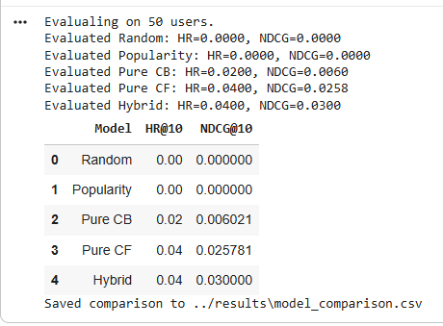

Evaluation Summary on 50 Users (HR@10 & NDCG@10 Results)

Discussion and Conclusion

The data preparation and exploratory analysis phases provide a comprehensive set of recommendations for developing a Sleep Quality Improvement Recommendation Engine to develop its content-based model; collaborative filtering model; hybrid recommendation model; and final evaluation of the overall system's performance.

This includes the method of converting item content (descriptions, features, and review text) into a vector space format (using TF-IDF). Additionally, user-item collaborative signal extraction takes place using user-item rating matrix and different neighborhood methods (i.e. SVD) and creating a weighted hybrid combined recommendation model provides an improved ranking quality for both new items and existing ones.
The exploratory analyses of the data, the dataset characteristics reveal the necessity for using content and collaborative approaches to recommendation. Dataset statistics printed below indicate an overall use of 5000 users, 520 items, and 51488 total ratings, resulting in sparsity value equal to 0.9802, or 98.02%. There is evidence that there is a non-uniform distribution of user activity and item popularity based upon the analysis. In addition, the long tail plot depicts a significa­ntly skewed item popularity (i.e., how many times an item is interacted with), which represents a major obstacle for most recommender systems because there are very few items that will be interacted with as frequently as the most popular items.
The Hybrid approach exhibited the best overall ranking performance through the testing of 50 users using the various recommended methods. The final evaluation results are as follows for each method tested; Random (HR@10 = 0.00, NDCG@10 = 0.000000), Popularity (HR@10 = 0.00, NDCG@10 = 0.000000), Pure CB (HR@10 = 0.02, NDCG@10 = 0.006021), Pure CF (HR@10 = 0.04, NDCG@10 = 0.025781), Hybrid (HR@10 = 0.04, NDCG@10 = 0.030000). The results of the evaluation demonstrate that collaborative filtering has provided a marked improvement in the ranking produced from content alone in this scenario, and that the weighted hybrid method has improved the NDCG@10 result when compared to Pure CF, while holding the same HR@10 result. The cold-start demonstration of users with 3, 5, and 10 ratings also indicated that the hybrid method is capable of tailoring the recommendations for those users with a limited history (for example, the recommendation system recommends multiple Sound & Environment items even if the users only had Sound & Environment items in their history) whereas the popularity baseline remains static across users reflecting the non-personalized nature of the recommendations.

